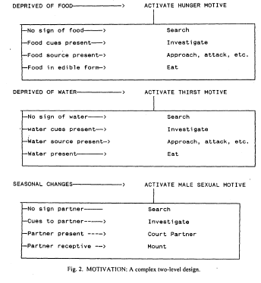

... [Therefore,] I have decided to lay claim to "motive" for my own purposes; i.e., to refer ONLY to the goal-directed organization of behavior, and NOT to the causes of that goal-directedness, whatever they may be. My conception of motivation is based on Sommerhoff's analogy to a self-aiming gun (Sommerhoff, 1950). Imagine a gun mounted on the prow of a ship. Further imagine that the gun is designed to shoot at the target: i.e., there is an array of target positions and an array of gun positions and a function between these two arrays such that the projectile from the gun is likely to strike the target.

Second, imagine a gun that is designed to shoot at surface targets. Once again there is an array of target positions and an array of gun positions and a correlation between them. But the function that connects the two arrays will be different in the two kinds of gun because a surface target is capable of different sorts of motion from an aerial target. For one thing, the trajectory of an aerial object is much more ballistic than that of a surface object. A surface object is much more able to twist and turn because of the greater mass of the material it is attached to.

Third, imagine a self-aiming gun that shoots at subsurface targets, such as torpedoes. As before, there is an array of target position and an array of gun positions and a function that relates them, and as before, this function must be different because of the medium in which the target is moving. In this case, the function must not only take account of the greater possibilities for evasive maneuver due to the target's contact with the water, but it must also take account of the water surface's capacity to refract light and its capacity to deflect a projectile that approaches at too shallow an angle.

Finally imagine that a military engineer has the bright idea of mounting a single gun on the prow of the ship that can shoot at all three kinds of targets. Guided by a complex computer program, this single weapon could behave in accordance with three different designs: one for aerial targets, one for surface targets, and one for subsurface targets. Each design would relate particular trajectories of the target to particular firings of the gun; and each of these designs would, in turn be related to the type of target. So, the gun would display two levels of design, the lower level that relates trajectory to firing and the higher level that relates the lower level design to target type.

The motivational structure of behavior is analogous to such a multifunction gun. To say that an animal is thirsty is to say that the animal "shoots at water": there is an array of circumstances relevant to water, an array of behaviors relevant to water-seeking, and a function that connects the two arrays such that the animal has a high probability of finding water. To say that an animal is hungry is to say that the animal "shoots at food": there is an array of circumstances relevant to food, an array of behaviors relevant to food-seeking, and a function that connects the two arrays such that the animal has a high probability of finding food. To say that an animal is sexually motivated is to say that the animal "shoots at sex": there is an array of circumstances relevant to sex, an array of behaviors relevant to sex-seeking, and a function that connects the two arrays such that the animal has a high probability of finding a sexual partner.

Of the three, hunger, thirst, and sex, sex is the only motive that is essentially social. Social motives characteristically involve a meshing of the design arrays of the participants: i.e., the behaviors of one participant's design arrays become the circumstances for the others'.

Like the multi-functioned gun, the animal displays a second, higher level of design. At this higher level, the design of the purposive system relates circumstances to the deployment of the lower level designs. Each of its designs, its design for water-seeking, its design for food-seeking and its design for seeking a partner of the opposite sex, is itself matched to a set of circumstances, the absence of water, the absence of food, and the seasonal circumstances appropriate to mating.

This conception of multiple hierarchical layers of design is a useful way to describe many of the phenomena that ethologists and socio-biologists are required to explain. …