 | Join George Duncan for his course (and other instructors for theirs) from the comfort of your home—wherever it may be—using Zoom. | 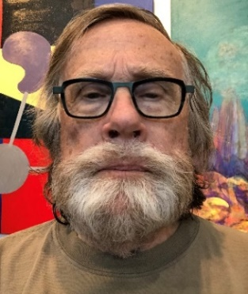
Renesan.org  Online registration for the Fall 2020 semester opens Monday, August 17 at 8am. Later registration is possible for presentation courses, such as George Duncan’s course. |  | George Duncan is teaching Citizen Politics and Political Polling in two sessions in October.

Citizen Politics and Political Polling

Instructor: George Duncan Tuesday: Oct 20, 27 10AM–Noon 2 sessions: $40

In citizen politics, people drive the democratic process because public opinion has a powerful yet inexact influence on elected officials. Politicians risk their careers if they ignore it, yet its power is not easy to capture nor quantify. In this course we examine the value and pitfalls of polling in assessing political opinions and voting behavior. Public opinion polling is an essential tool in public policy decision making, election campaigns, and media reporting. This course focuses on the design, use, and critical interpretation of election campaign surveys. Topics include sample size, timing, assessing likely voters, the content and order of survey questions, and gauging potential for political contributions.

George Duncan is Emeritus Professor of Statistics and Public Policy at Carnegie Mellon University. He earned BS and MS degrees at the University of Chicago and a PhD at the University of Minnesota. A Fellow of the American Statistical Association, the Royal Statistical Society, and the American Association for the Advancement of Science, he chaired the National Academy of Sciences Panel on Confidentiality and Data Access. He served as a Peace Corps Volunteer in the Philippines and is a Board Member of the Museums of New Mexico Foundation. His last class at RENESAN was “The Birth of Mathematics” in Spring 2019.

