Conversations with Co-Creator of NASA’s Webb Telescope

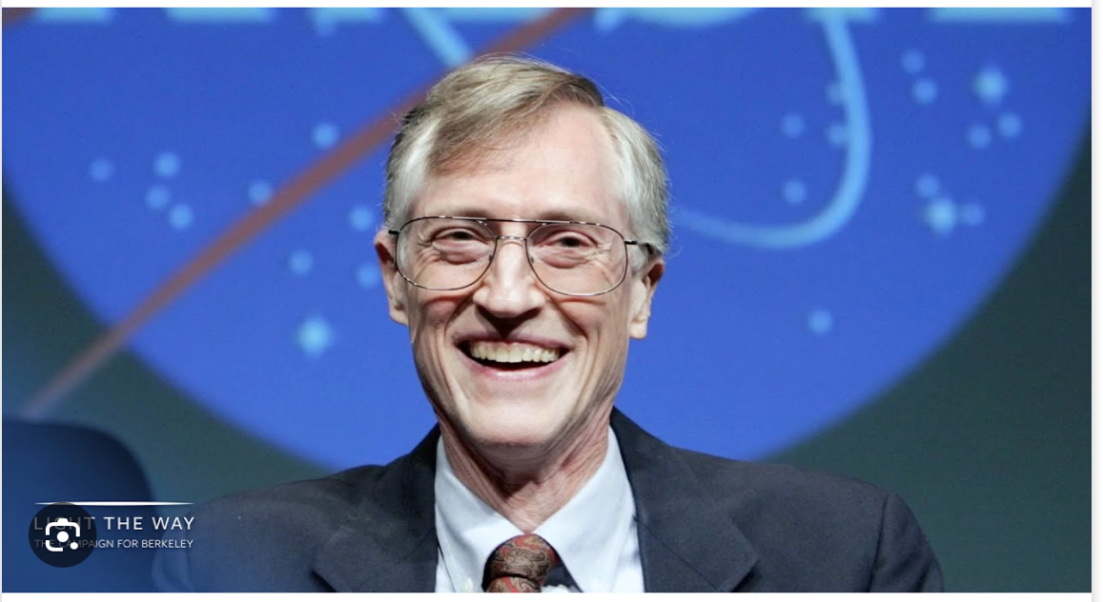

John Mather was the lead physicist of the NASA team which created the James Webb Telescope, and a recipient of the 2006 Nobel Prize in Physics for researching the Big Bang theory’s validity through precise measurements of cosmic microwave background radiation. He was featured in Time Magazine’s “100 Most Influential People” (2007) and “25 Most influential People in Space” (2012), and is reported to have “inspired generations of scientists and the public with his discoveries and passion for understanding the universe.” (bard.google.com)

Santa Fe Freethinkers Forum invites you to an evening with Dr. Mather, on Wed. Jan 24 at 7 pm at UU Santa Fe on the corner of Barcelona and Galisteo. When John was last in Santa Fe as a guest of Santa Fe Institute, people commented on how charismatic he is - “astrophysicist” and “charismatic” not being terms which are often used in the same sentence! Welcome to a chance to exchange ideas with this warm, open-minded scientist who has played a leading role in expanding our views of the universe.

Dr. Mather will give a presentation with visuals from the Webb Telescope, its creation and some of the amazing pictures it has produced, followed by time for questions and conversation. What new information has the Webb given us about our universe? What surprises has it brought us? What are your dreams for the future? Following the full group conversation, there will be time for personal interactions over light refreshments. For further info go to https://www.meetup.com/freethinkersforum/ or call 505 231-1447.

