**WHY WESTERLIES?**

**The very short answer to the question of why our American winds generally blow from the west is that hot air is trying to escape from the tropics but is thwarted by the Coriolis Force. The earth is [nearly] a sphere tilted 23 degrees away from the sun. Over the whole year, the sunlight is about 40% more intense in the tropics and about 40 % less in the poles than it is in the midlatitudes where we live. In the summer, this difference becomes less as the sun “moves” north; in the winter, however it increases dramatically so that the tropical sun is almost three times as intense as the midlatitude sun and polar sun almost two thirds weaker.  *[data and graphs courtesy George Patrick Tremblay, IV.]***

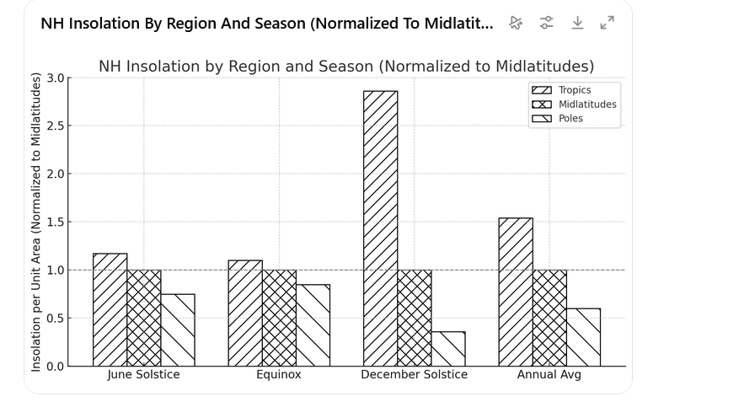

**Nature abhors a gradient. With all this heat building up in the tropics you would think that it would be trying to find a way to escape poleward. And it does, in the form of hot air trying to stream north at high altitudes. The hot tropical earth heats the air at the surface, the air rises over the tropics and then tries to flood northward. But here the Coriolis force kicks in.**

**Imagine yourself on a merry-go-round that is spinning in a clockwise direction. You are once again a teenager, and you and your pal are being rowdy. Crouching on one of the horses in the outside ring, you try to leap to the horse beside it in the inside ring, but you keep missing. Even though you jump right toward it, you keep falling over the horse’s nose. Meanwhile, when you buddy on the inner ring tries to jump to your horse, he falls on its rump. So, like the rowdy teenagers you are, you experiment, and you discover with a little practice that you can jump directly at one another from side-by-side horses, and never bump into each other. In fact, you will end up one horse apart in separate rows. Given that all the horses are turning at the same number of rotations per second, how could this be?[1]**

**The reason is that even though all the horses are turning at the same rpm, the horses in the outer ring are moving faster. I always have to grit my teeth when I say this because it seems so counter-intuitive: *two objects, bolted to the same rigid surface, and yet one is moving faster than the other*?! If you ponder the situation for moment you will see that it just must be true. Let’s say the circumference of the circle of inner horses is half that of the outer horses. In that case the inner horses must traveling half the distance of the outer horses, even though they remain neck-and-neck all the way around. If they are traveling ha the distance in the same time, they *must* be traveling around thw circle twice as fast. After all, distance per unit time is what speed *is*. Do we wonder that race horses “jockey” for the inside track!? Such is life on a rotating world. Poised to leap toward the center, the outside teenager is moving to the right twice as fast as the inside teenager and, until he lands in the inner ring, he continues to do so. To try to make such rotating worlds make sense, physicists have invented the Coriolis force to push objects forward around the circle when they move toward its center and push objects backward on the circle when they move towards its circumference. Notice that wherever objects move on a rotating circle, the Coriolis force will always push them to the right.**

**What is true for hoodlum leapers on a merry-go-ground is true of hot air fleeing the tropics at high altitudes. Each step it takes to the N, it is bent to the right so that by the time it reaches our latitudes in the US, it is flowing generally westward. This is why the wind blows generally from the west in the United States. And it is also why the air blows from the east in the tropics. Because air is moving out from the tropics it must be replaced from the North. But southward moving air is also thwarted, so just as the winds in the US tend to blow from the west, so the winds in the Caribbean tend to blow from the east.**

1. Don’t try this at home. The specifications that make this feat possible are stringent. For instance, the merry- go-round must be about 60 ft across and rotating at 8 revolutions per minute. The two rings of horses must be about 10 feet apart. The jumpers must be in the air 1.8 seconds. And, of course, the horses must be spaced just right. These conditions are only barely plausible. However, if they were met, two jumpers looking to trade horses would jump past one another end up one horse ahead and behind their respective targets.